# CS 340

Vince Taliaferro

8/10/2023

## About the Project/Project Title

*Grazioso Salvare* is an international rescue-animal firm that specializes in training. They have asked Global Rain software development to create a dashboard that gathers and displays data for the animals they currently have in their possession. Using this dashboard to show good potential candidates for things like search and rescue training based on specific traits like breed, gender, and how old the animal is. Using three key features to include a data table, chart, and map of the location where the animal currently resides.

Interactive options to filter the Austin Animal Center Outcomes data set.

A data table which dynamically responds to the filtering options.

A geolocation chart and a second chart of your choice that dynamically respond to the filtering options.

## Getting Started:

MongoDB was used as the backend for our project. We used MongoDB for the fast setup of the databases and works well alongside Python and the Dash framework. The front-end that we developed was Dash with Jupyter notebook that is a web-based program. Dash is a framework that is open source based in Python that helps organize the interfaces like the dashboard we created in this project.

*Create the database in MongoDB, importing the csv file and authenticating the user like the example shown below.*

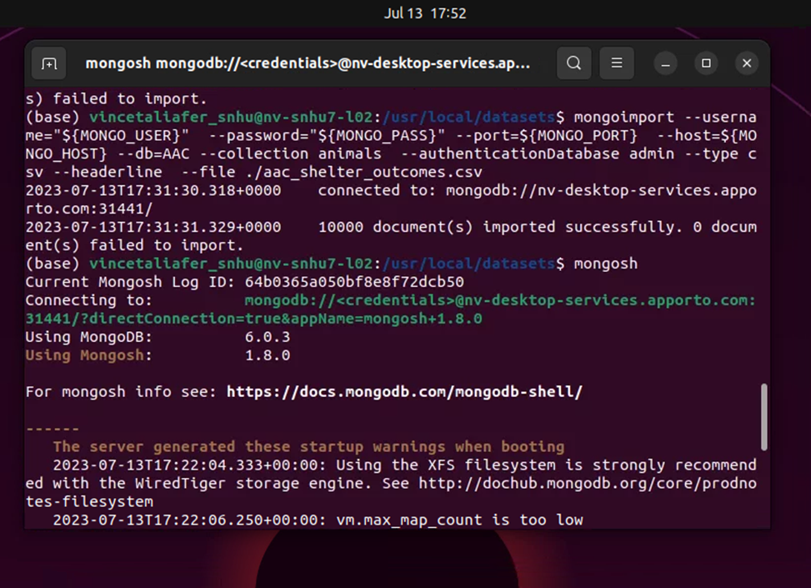

*We must then create a user with the read/write perms in place to enable user authentication.*

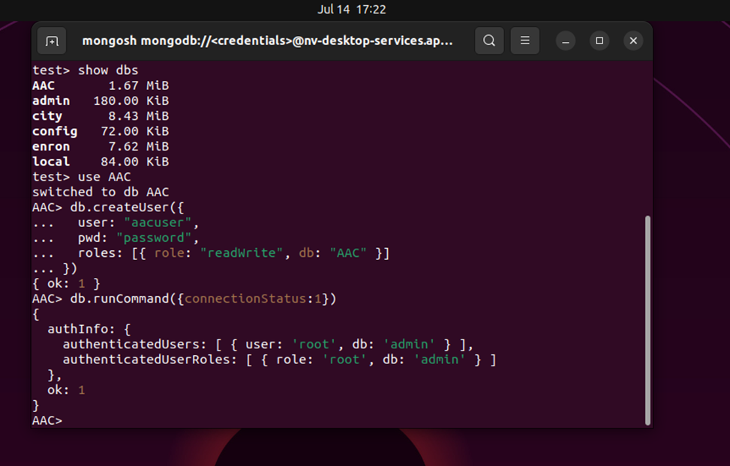

This is the implementation that we used to download the CRUD file. With self.client = MongoClient(‘mongodb:// *://%s:%s@localhost:38888/AAC’ % (username, password))* you can change the port number to your own specific to install the file into the directory.

We must import the CRUD module properly



Enter your username and password.

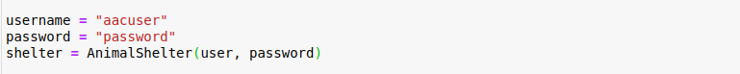

*The framework Dash uses HTML and Python programming to make the dashboard after we import the CRUD module while updating the username and password. We need the data table layout like the one below.*

*Creating an app.callback to filter interactive data tables.*

*This is the code developed to create the chart and map.*

*Chart:*

*Map:*

*Usage:*

*After creating the MongoDB database and loading the animalshelter.py and Project Two jupyter file. We will be able to run this program. After opening the file and running it, you would see the chart along with the map to locate a certain animal traits associated with them. We can add filters and change the functionality of the chart and map to find specific training for the breed that a person is looking for.*

*Challenges encountered:*

*I encountered more challenges this term than any other in my journey through SNHU for my Computer Science degree. In the middle of the term, I was asked to go to a work conference in Anaheim, California. It was a life-changing experience, but it came at the cost of disrupting my studies in the middle of the two most difficult courses I have encountered to date. Needless to say, I am ready to get a new start and get through the last few months of a bachelor’s degree that I thought was never possible. This project was a test of skill and dedication that I one day would like to achieve. I hope that the next term proves to be a new start for me, and I can continue this journey into the world of Software Development. It reminds me of a quote from J.F.K.*

*“We choose to go to the moon in this decade and do the other things, not because they are easy, but because they are hard.”*

*[Address at Rice University, September 12, 1962]*

*― John F. Kennedy*

## Contact

Your name: Vince Taliaferro